Problem Solving with Ratio and Proportion

Name: _____________________________________
Class: _____________________________________

Time: 1 hour 20 mins
Total marks available: 70 | Total marks achieved: _____

Q1.
* The normal price of a denim shirt at a shop is £9.60
On Special Offer Day, there is off the normal price.
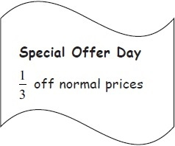
Billy has £13
Has he enough money to buy two denim shirts on Special Offer Day?
You must show all your working.
(Total for Question is 4 marks)

Q2.
Shazia buys 10 boxes of drinks.
The cost of each box of drinks is £5
Each box holds 12 cans of drink.
Shazia sells of the total number of cans for 60p each.
She then sells all the remaining cans for 30p each.
Work out the total profit that Shazia makes.

(Total for question = 5 marks)

Q3.
Liam, Sarah and Emily shared some money in the ratio 2 : 3 : 7
Emily got £80 more than Liam.
How much money did Sarah get?

(Total for question = 3 marks)

Q4.
There are 500 passengers on a train.
of the passengers are men.
40% of the passengers are women.
The rest of the passengers are children.
Work out the number of children on the train.
...........................................................

(Total for question is 3 marks)

Q5.
Mr Mason asks 240 Year 11 students what they want to do next year.
15% of the students want to go to college.
³⁄₄ of the students want to stay at school.
The rest of the students do not know.
Work out the number of students who do not know.

. . . . . . . . . . . . . . . . . . . . . .
(Total for Question is 4 marks)
Q6.
Sapir buys 60 bags.
She pays £3 for each bag.
Sapir sells ½ of the bags for £5 each.
She sells ¹⁄₃ of the bags for £4 each.
Sapir wants to make a total profit of £75
How much should she sell each of the remaining bags for?

£...........................................................
(Total for Question is 4 marks)

Q7.
Sam buys 20 boxes of oranges.
There are 25 oranges in each box.
Each boxes of oranges costs £7
Sam sells of the oranges he bought.
He sells each of these oranges for 40p.
He then sells each of the remaining oranges at 3 oranges for 50p.
Did Sam make a profit or did Sam make a loss?
You must show working to justify your answer.

(Total for question = 5 marks)

Q8.
Mr Brown and his 2 children are going to London by train.
An adult ticket costs £24
A child ticket costs £12
Mr Brown has a Family Railcard.
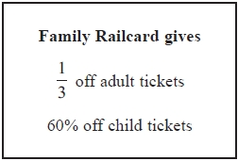
Work out the total cost of the tickets when Mr Brown uses his Family Railcard.
£...........................................................
(Total for Question is 4 marks)

Q9.
Rachel bought a packet of 60 balloons.
of the balloons were yellow.
of the balloons were red.
The rest of the balloons were blue.
How many of the balloons were blue?
........................................................... balloons

(Total for question = 3 marks)

Q10.
* Two shops, Mega Bathrooms and Bathroom Mart, each have a sale.
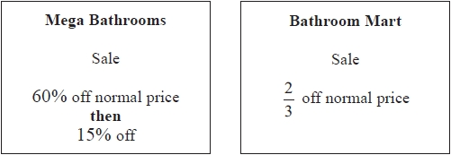
Sally wants to buy some bathroom units.
The units have a normal price of £1500
Sally wants to buy the units as cheaply as possible.
Which shop should she buy the units from?
You must show all your working.

(Total for question = 4 marks)

Q11.
Greg sells car insurance and home insurance.
The table shows the cost of these insurances.
Insurance | car insurance | home insurance
Cost | £200 | £350
Each month Greg earns
£530 basic pay
5% of the cost of all the car insurance he sells
and 10% of the cost of all the home insurance he sells
In May Greg sold
6 car insurances
and 4 home insurances
Work out the total amount of money Greg earned in May.

..............................................................................................................................................
(Total for Question is 5 marks)

Q12.
* Orange squash is used to make orange drink.
Jill is going to make orange drink for 50 people.
She is going to make 2 full glasses of orange drink for each person.
She needs 250 millilitres of orange drink for each glass.
Here are the instructions for making orange drink.
Mix 1 part of orange squash with 4 parts of water.
A one litre bottle of orange squash costs £2
Work out the total cost of the bottles of orange squash Jill needs to buy.
(1 litre = 1000 millilitres)

(Total for Question is 5 marks)

Q13.
In a company, the ratio of the number of men to the number of women is 3:2
40% of the men are under the age of 25
10% of the women are under the age of 25
What percentage of all the people in the company are under the age of 25?

........................................................... %

(Total for question = 4 marks)

Q14.
Helen has 80 books to sell.
Each book is Fiction or Non–fiction.
The ratio of the number of Fiction books to the number of Non–fiction books is 3:1
Each book has a normal price of £10
Helen reduces the price of all the Non–fiction books.
Helen sells all 80 books.
Work out the total amount of money Helen will receive.

£ ...........................................................

(Total for question = 4 marks)

Q15.
A charity made an appeal for money.
The charity put the information shown below on a poster.
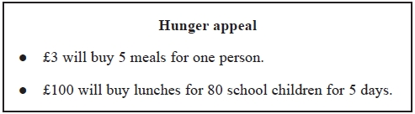
£3 will buy 5 meals for one person.
(a) Work out the cost of one of the meals.
Give your answer in pence.
...........................................................p
(2)
£100 will buy lunches for 80 school children for 5 days.
(b) Work out the cost of buying lunch for one school child for one day.

...........................................................
(3)
(Total for Question is 5 marks)

Q16.
5 schools sent some students to a conference.
One of the schools sent both boys and girls.
This school sent 16 boys.
The ratio of the number of boys it sent to the number of girls it sent was 1 : 2
The other 4 schools sent only girls.
Each of the 5 schools sent the same number of students.
Work out the total number of students sent to the conference by these 5 schools.

..............................................................................................................................................
(Total for Question is 4 marks)

Q17.
A supermarket car park has 200 spaces.
10% of the spaces are for staff.
The other spaces are for disabled people, for parents and for other customers in the ratio 1 : 2: 7
Paul is going to paint a sign for each of the spaces for staff, for disabled people and for parents.
He is not going to paint signs for the spaces for other customers.
Work out the total number of spaces Paul is going to paint a sign for.

...........................................................

(Total for question = 4 marks)

