Solving Quadratic Inequalities RED

Solution of quadratic equation | Graph showing inequality region | Solution of inequality
(x + 4)(x – 7) = 0  x = -4, x = 7 | 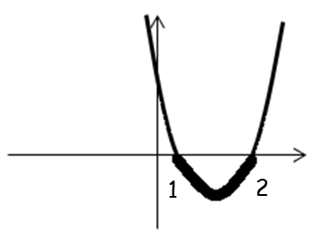 | -3 < x < 6
(x + 3)(x + 4) = 0  x = -3, x = -4 | 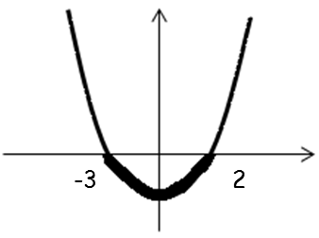 | 5 ≤ x ≤ 7
(5x – 1)(x – 2) = 0  x = 1/5, x = 2 | 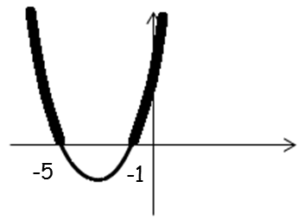 | 1 < x < 2
(x + 3)(x – 2) = 0  x = -3, x = 2 | 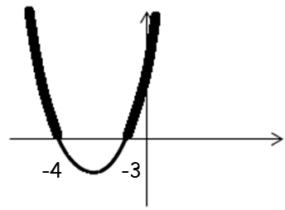 | 3 < x < 5
(x – 3)(x – 5) = 0  x = 3, x = 5 | 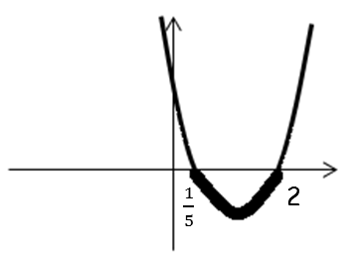 | x < -5  x > -1
(x + 5)(x + 1) = 0  x = -5, x = -1 | 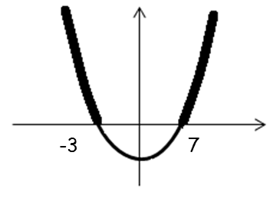 | x ≤ -3  x ≥ 7

Solution of quadratic equation | Graph showing inequality region | Solution of inequality
(x – 7)(x – 5) = 0  x = 7, x = 5 | 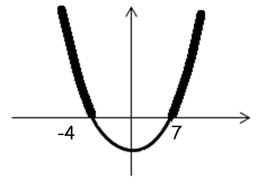 | -3 ≤ x ≤ 2
(x – 5)(x + 3) = 0  x = 5, x = -3 | 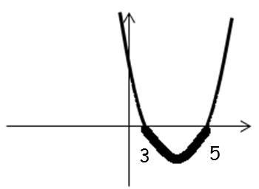 | x ≤ -3  x ≥ 5
(6 – x)(3 + x) = 0  x = 6, x = -3 | 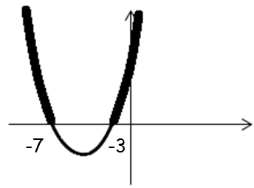 | x ≤ -7  x ≥ -3
(x – 2)(x – 1) = 0  x = 1, x = 2 | 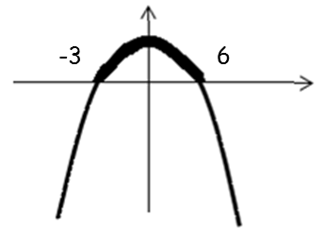 | x ≤ -4  x ≥ -3
(x + 7)(x + 3) = 0  x = -7, x = -3 | 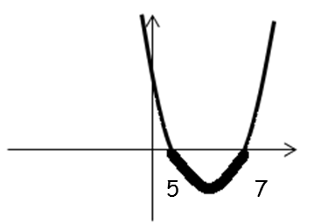 | x < -4  x > 7
(x – 7)(x + 3) = 0  x = 7, x = -3 | 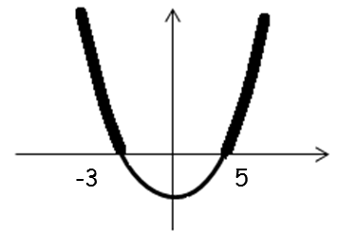 | $\frac{1}{5}$ ≤ x ≤ 2

